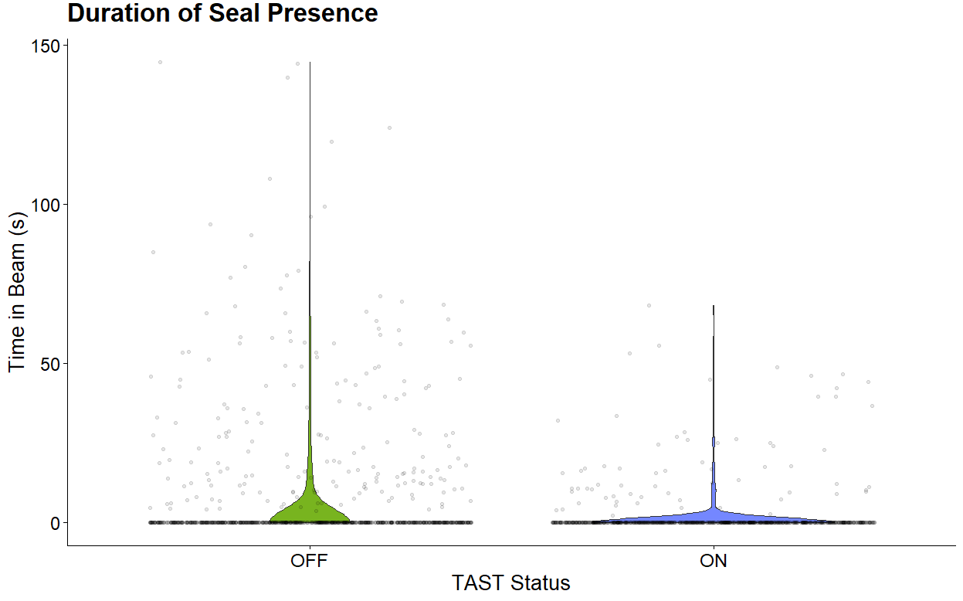
Figure 1. Violin plot showing the duration of seal presence within the study area for both TAST treatments.

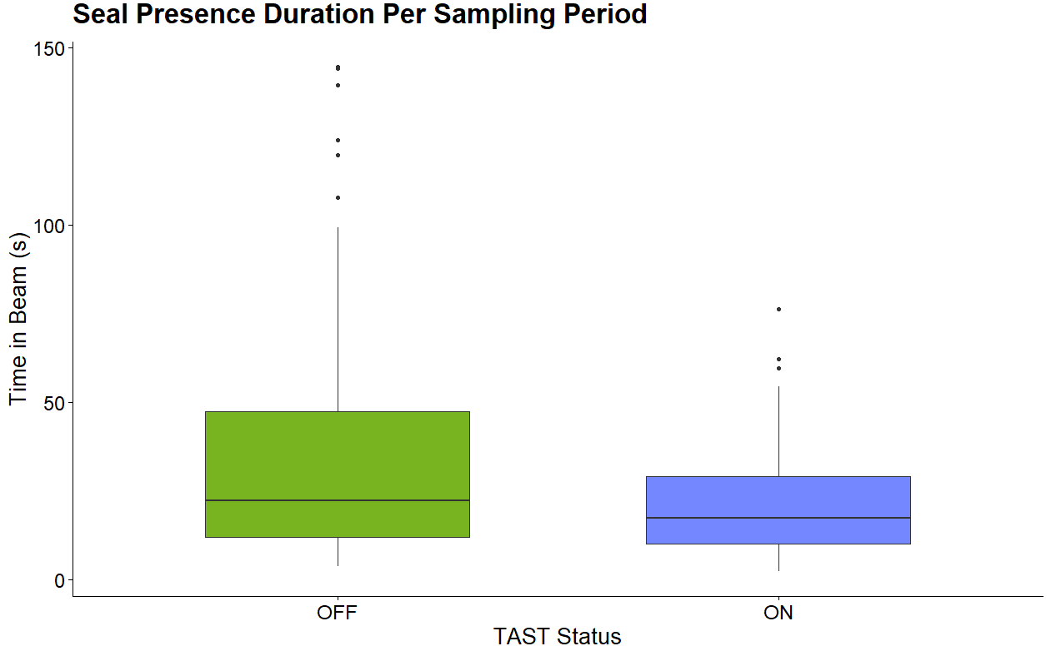
Figure 2. Box plot showing the duration of seal presence for each treatment.
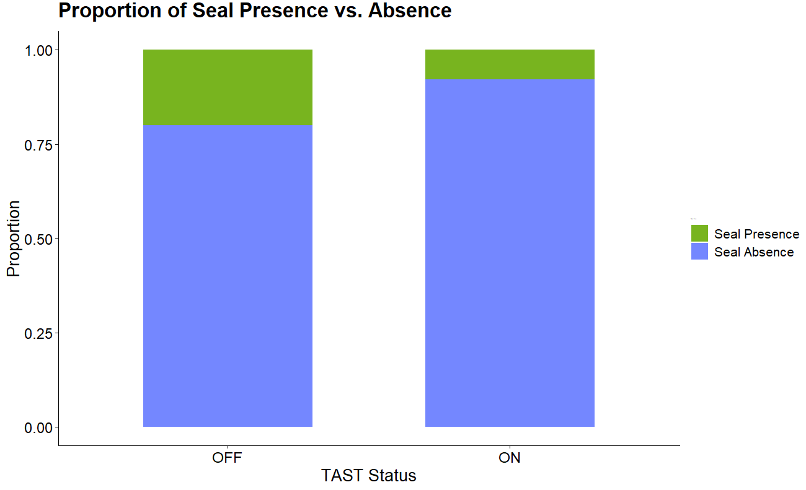
n = 798
n = 770

Figure 3. Stacked bar plot showing the proportion of files that contained or did not contain seals for each treatment.

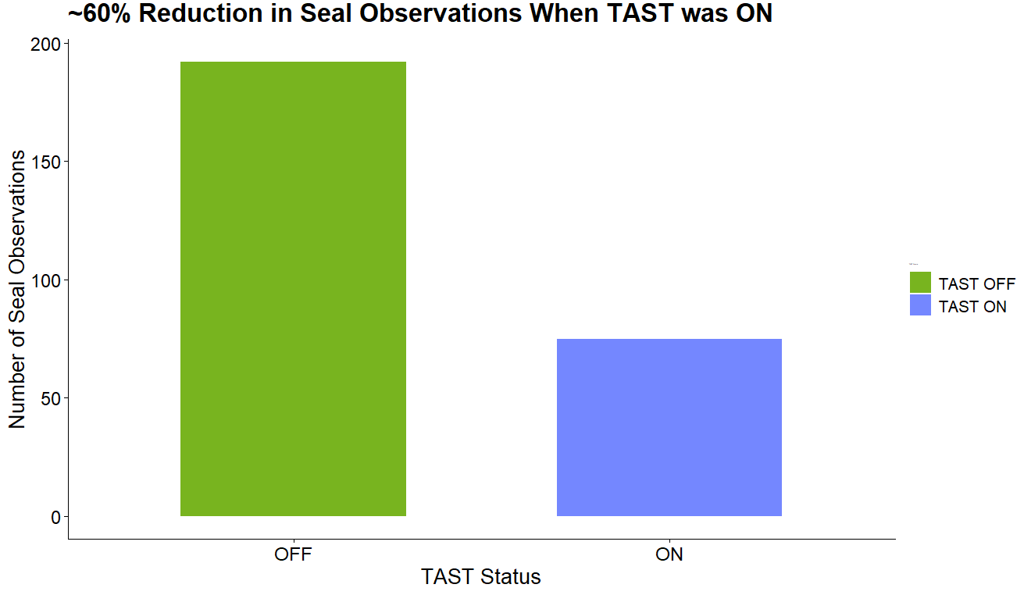
Figure 4. Bar plot showing the number of seal observations for each treatment. A ~60% percent reduction in seal observations was observed when the TAST was on.
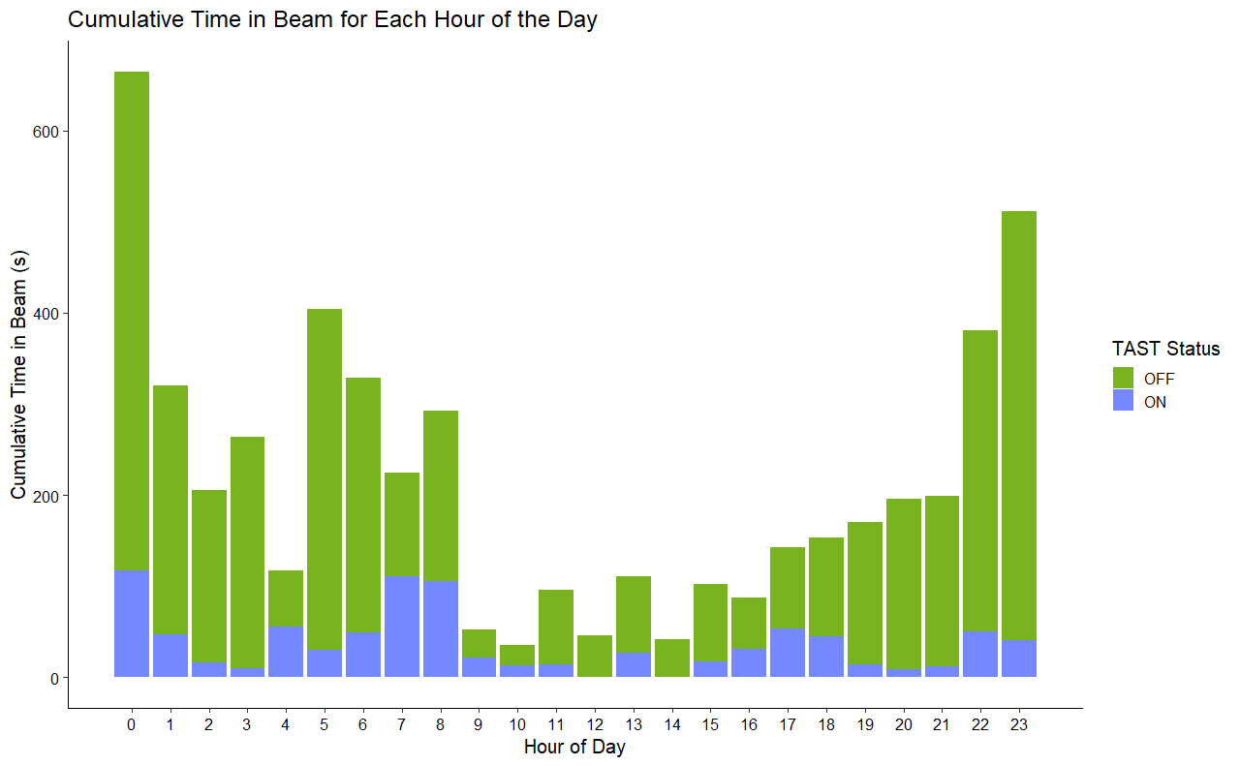
Figure 5. Stacked bar plot showing the cumulative time that seals spent inside the study area for each hour of the day (24-hr time).
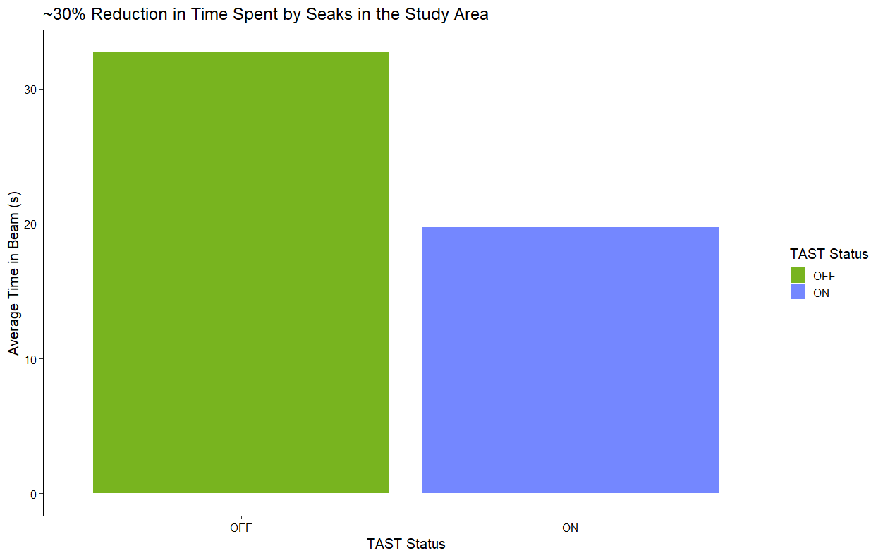
Figure 6. Bar plot showing the average amount of time that seals spent inside the study area for each treatment. A 30% reduction in the amount of time that seals spent inside the study area was observed.

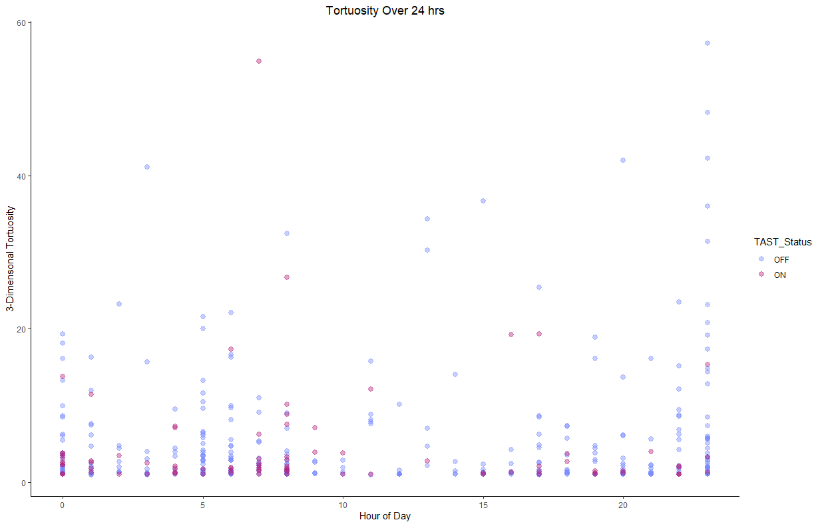
Figure 7. A point plot of seal tortuosity over a day for each treatment (24-hr time).
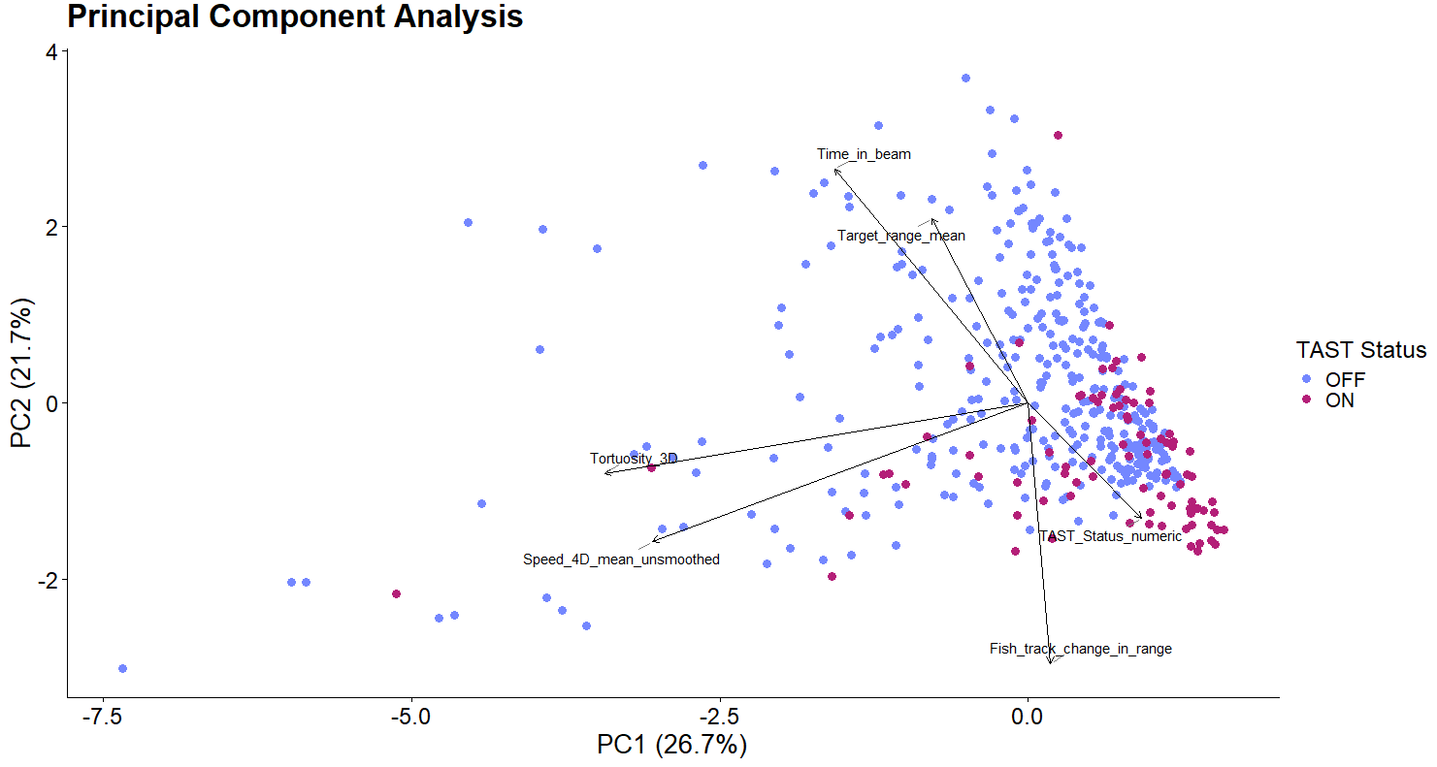
Figure 8. A principal component analysis of metrics generated from seal tracks in EchoView.
n = 770
n = 798

